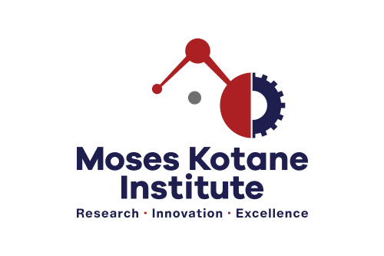

**CALL FOR APPLICATIONS:**

**INDEPENDENT CONTRACTOR: STATISTICAL SERVICES (X1)**

**Ref –** **IC/STATS -S 03/2022**

**BACKGROUND** The Moses Kotane Institute (MKI) is looking to secure the services of an experienced and suitably qualified South African Citizen to assist with – Statistical Services. The successful candidate will be responsible for assisting with research activities within the Econometrics and Statistical Service Unit. The role will be on a project and assignment basis

**MINIMUM REQUIREMENTS** Applicants must have an Honors Degree in Statistics/Economics or related field from an accredited tertiary institution. At least 2 years in research and data analysis role with a strong focus on data collection tool design, implementation, and statistical data analysis. Driver’s License.

**CORE COMPETENCIES** Excellent verbal and written communication skills. Analysis and problem solving. Good understanding of the procedures used in gathering and  reporting statistics. Excellent organizational skills and attention to detail. Proficient in Microsoft Office Excel and at least one statistical software package.

**RESPONSIBILITIES** Conduct assigned research; Present research findings to relevant stakeholders. Assist with development and implementation of data collection systems to optimise to improve efficiency and data quality. Conduct data analysis and interpretation using statistical tools and provide reports. Assist with database management to ensure data quality and integrity. Provide project management support and assist with administrative duties related to a research project.

**TERMS OF APPOINTMENT** The successful candidate will be offered an Independent Contractor contract (up 6 months) on an hourly rate of R368 p/h

**HOW TO APPLY** Interested candidates must email a detailed copy of a CV with at least 2 (two) contactable references, certified copies of ID, driver’s license and relevant qualifications (not older than 6 months) to: [maritimeeconomics@moseskotane.com](mailto:maritimeeconomics@moseskotane.com) before or on **24 October 2022**. Shortlisted candidates may be taken through a verification process.

Applications not compliant with the prescripts herein, will not be considered. For any technical queries contact The Human Resources Manager, on [Nompilo.Mngoma@moseskotane.com](mailto:Nompilo.Mngoma@moseskotane.com) Candidates who have not heard from MKI within 2 weeks from the closing date, may consider their application unsuccessful. Applicants will be disqualified for any incorrect information supplied. The Institution reserves the right not to appoint.