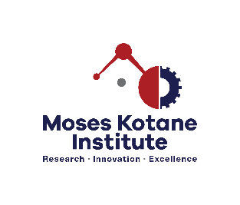

CALL FOR APPLICATIONS FOR FUNDING
COMMERCIALISING INNOVATION AND RESEARCH (CIR)
REF: MKIRF04

BACKGROUND

The Moses Kotane Institute (MKI) is a leading research institute in growing the economy through research and development in KwaZulu-Natal. It develops practical research-based solutions that contribute to the needs of the provincial economy by using research recommendations towards policy development and service delivery interventions. As part of development, a funding opportunity exists for researchers, innovators, entrepreneurs and SMMEs who wish to bring their research and innovative products or solutions to life through commercialisation.

REQUIREMENTS
- Projects that have been piloted (proof of concept, tested /evaluate / assessed / prototyped, etc.) to activate commercialisation.
- Projects that seek to innovatively solve KZN socio-economic challenge/s.
- South African researchers, innovators, entrepreneurs and SMMEs residing in KwaZulu-Natal.

REQUIRED DOCUMENTS (Submission of the following documents is mandatory)
- Certified copies of Identity Document
- Proof of residence
- Company profile (with the CV of the Director) OR the applicant’s CV (in the case of individuals)
- Written proposal (well-articulated problem/challenge, solution, benefit to the province) not exceeding 5 pages including a detailed budget (financial) breakdown of funds requested, describing clearly what the funds will be used for in an itemised manner.

DISQUALIFICATION
- Applicants who do not meet the requirements.
- Applications received after the closing date.
- Non-submission of the required documents
- Applications not submitted to the designated email address

COMMUNICATION
• English / IsiZulu

HOW TO APPLY:
Interested applicants must email all the required documents to researchfund@moseskotane.com on or before 31 October 2022 (closing date). Shortlisted applicants will be required to present/demonstrate their products/solutions before a panel.

PLEASE NOTE
- Applicants that applied in the previous cycle are encouraged to re-apply.
- Research and innovation fund is subject to availability of funds. MKI reserves the right not to award funding.
- Applicants who have not heard from MKI within two weeks of closing, may consider their application unsuccessful.

