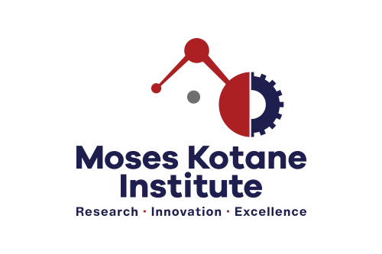

**EXPERIENTIAL LEARNER : OFFICE OF THE CEO**

**(REF -EL/2LR 03/2022)**

**CLOSING DATE : 24 OCTOBER 2022**

**BACKGROUND** The Moses Kotane Institute is looking to appoint a suitably qualified South African unemployed youth interested in gaining experience within the research field.

**MINIMUM REQUIREMENTS** Applicants must have a valid Master’s degree, from an accredited tertiary institution, specializing in Economics, Geography (with GIS), Statistics, or related qualification with a clear focus on socio-economic research or social sciences. At least two years’ experience in research-writing. Proficient user in one of the following statistical software (Stata, R-package, and Python)- Assessment test will be written. A valid Driver’s license will be an added advantage.

**RESPONSIBILITIES**  Conduct literature review, contribute towards drafting proposals, assist with leading data collection and data capturing, report writing, assist running online repositories and provide general administration support where required.

**CORE COMPETENCIES**  Demonstrate the willingness to learn ; Competent PC user and can work remotely with minimal supervision. Dynamic and highly committed to working in a fast-paced environment. Excellent analytical skills, attention to detail and ability to follow set deadlines, good verbal and writing skills; Good time and project management skills, and willing to work long hours.

# 

**TERMS OF APPOINTMENT** The successful candidate will be offered a 12-month fixed term contract, remunerated at **R16 000.00 (TCOE**)

**HOW TO APPLY** Interested candidates must e-mail a detailed copy of a CV with at least 2 (two) contactable references, certified copies of ID, driver’s license, and relevant qualifications (not older than 6 months) to: **adverts@moseskotane.com** before or on **24 October 2022**. Shortlisted candidates may be taken through a verification process.

Applications not compliant with the prescripts herein, will not be considered. For any technical queries contact the Human Resources Manager, on Nompilo.Mngoma@moseskotane.com. Candidates who have not heard from MKI within 2 weeks from the closing date, may consider their application unsuccessful. Applicants will be disqualified for any incorrect information supplied. The Institution reserves the right not to appoint.