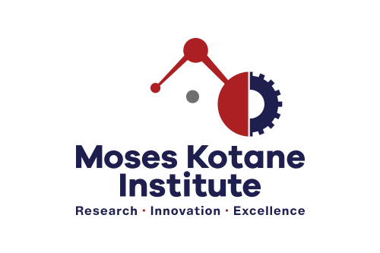

**CALL FOR APPLICATIONS**

**INDEPENDENT CONTRACTOR: BUSINESS DEVELOPMENT SPECIALIST (X1)**

**(REF -IC/BDS-04/2022)**

**BACKGROUND** The Moses Kotane Institute (MKI) is looking to secure the services of an experienced and suitably qualified South African Citizen to assist within the Economics and Statistical Services to assist in successfully completing a scheduled project: KZN Traditional Horseracing (THR) sector value chain analysis and business model development in KwaZulu-Natal .

**MINIMUM REQUIREMENTS** A minimum of a valid Honours degree from an accredited tertiary institution, in Economics, Business Administration, Finance, or related qualification. Minimum of 5 years work experience in business model development or value chain analysis or similar work experience. Professional membership in project management or other relevant professional body would be an added advantage. A commercial Master’s degree would be a distinct advantage.

**CORE COMPETENCIES** Business acumen and sound financial judgement; Capacity to use reputable research strategies and logical critical analysis; Advanced MS Excel knowledge; Exceptional interpersonal, writing, and verbal communication skills; Strong project management capabilities; Capacity to uphold safety, quality, and data control requirements. Independence; Team player; Attention to detail and thoroughness; Problem-solving skills; Presentation skills; Computer skills. A sense of urgency and positive attitude.

**RESPONSIBILITIES**  **Sector Value Chain analysis**: Conduct sector value chain analysis for the KZN Traditional Horseracing sector.

**Business Model Development:**

Conduct market research to provide benchmarking and market structure. PESTEL analysis will be required. Identify the key supply drivers. Establish feasibility with cost structures and revenue models. Describe the Product life cycle. Create financial model with short- and long-term valuation. Recognise the market risk factors. Develop a business model for the THR sector in KZN.

# 

**TERMS OF APPOINTMENT** The successful candidate will be offered an independent contract (up to four months) on an hourly rate of R368 p/h.

**HOW TO APPLY** Interested candidates must e-mail a detailed copy of a CV with at least 2 (two) contactable references, certified copies of ID, driver’s license, and relevant qualifications (not older than 6 months) to: **maritimeeconomicsadverts@moseskotane.com** before or on 24 October 2022. Shortlisted candidates may be taken through a verification process.

Applications not compliant with the prescripts herein, will not be considered. For any technical queries contact the Human Resources Manager, on Nompilo.Mngoma@moseskotane.com. Candidates who have not heard from MKI within 2 weeks from the closing date, may consider their application unsuccessful. Applicants will be disqualified for any incorrect information supplied. The Institution reserves the right not to appoint.